Clinical Waste
Content Changes 2016-2018 Revision Guide
All page numbers refer to the 2016-2018 Revision Guides with red covers.

Section 1: Clinical Waste Storage, page 11
Two new rows were added to the table showing the colour and type of container used for different clinical waste types.
Waste Type | Waste Receptacle | EWC Code | Description
Other medicines (in original packaging) | Two blue-lidded, rigid yellow containers (one for solid, one for liquid) | 18 01 09 or 18 02 08 and/or 20 01 32 | Clinical waste, medicines (not cytotoxic and cytostatic) from animal/human healthcare, for incineration only
Other medicines (not in original packaging)

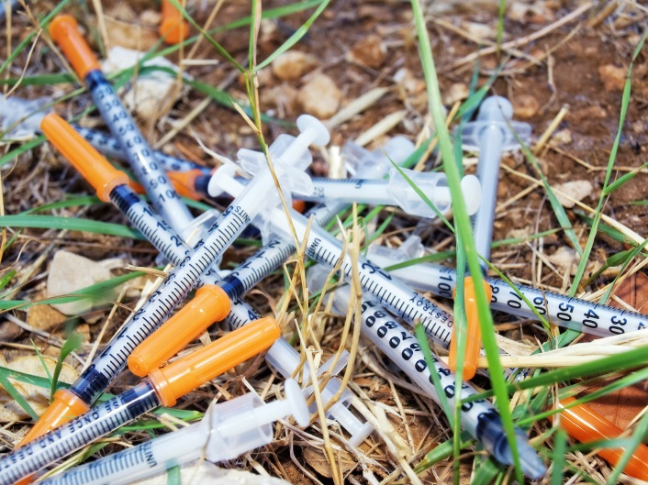

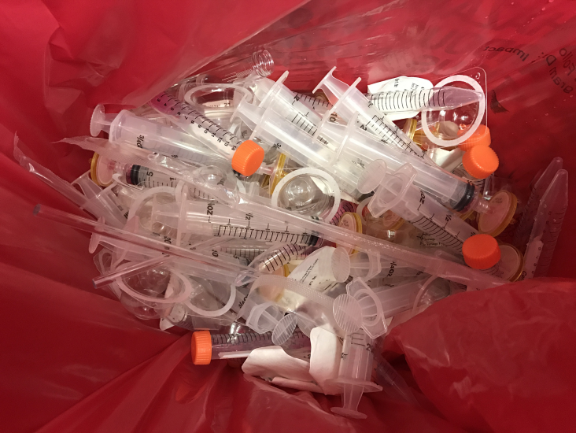

Section 1: Safe Storage and Labelling, page 14
New content: All clinical waste should be kept in totally enclosed, clearly labelled and secure areas sited on impermeable pavement with a sealed or foul drainage system.

Section 3: Consignment Notes, page 23

Section 3: Consignment notes, page 23
The learning outcome ‘3.3 Know the process for the consignment notes if rejecting a load of hazardous healthcare waste’ was added to the syllabus.
Hazardous Waste Returns
Hazardous waste consignee returns are completed to inform the environmental regulators about the hazardous waste consignments that have been received, removed or disposed at a site.
They are a compulsory requirement of the Hazardous Waste Regulations 2005 and should include any hazardous waste loads you have rejected from site.
What if a waste load arrives without a consignment note?
You may commit an offence if you (or another party) create a consignment note when the waste arrives at your site.
Under these circumstances, you must create a written explanation outlining the reason the

waste is being rejected, a description of the waste, the names of the producer, holder, consignor and carrier.
Section 4: Pre-acceptance and Acceptance, page 27
New content: If the inspection or analysis indicates that the waste fails to meet the acceptance criteria, then store such loads in a dedicated quarantine area and deal with them appropriately.

Revised List of Sources
Page | Source
12, 13, 14, 32, 33 | Health Technical Memorandum 07-01:Safe Management of Healthcare Waste
12, 13, 14, 32, 33 | WHTM 07-01 Welsh Health Technical Memorandum
12, 13, 14 | HSE Guidance: Management of Healthcare Waste
14, 16, 19, 27, 28, 29, 33 | Environment Agency (2011) How to comply with your environmental permit: additional guidance for clinical waste
14, 16, 27, 28, 33 | NRW (2014) How to comply with your environmental permit: additional guidance for clinical waste
19 | Environment Agency (2015) Waste Classification: Technical Guidance WM3
24 | GOV.UK – Hazardous Waste
24 | NRW – Hazardous Waste Returns
24 | Your waste – your responsibility (Duty of Care)
Please note: this information was correct at the time of publishing. If you find these links are broken, type the document title into a search engine.

About this sheet
The Continuing Competence Free Update Sheet is designed to be used by purchasers of the Continuing Competence Revision Guides for the 2016-2018 period.

It will highlight any changes in technical guidance and sources used as a basis for the Continuing Competence question bank to support the revision of users.

Frequently Asked Questions (FAQs)
How much does the test cost?
Each test costs £139 irrespective of the number of Activity Specific Tests chosen (a maximum of three activity specific tests can be taken at one time).
What form of personal identification can I use at the test centre?
- A valid signed passport of any country with your photograph and signature.
- A valid signed UK photo card driving licence (full or provisional).
- If you have none of these, you may present a Citizen’s ID Card.
How can I find out if I have passed the test?
At the end of the test you will receive your score report which provides the scores for each component of the Generic Knowledge Test and the score for each Activity Specific Test you have taken.
There is an example on the back of your score report showing how to work out if you’ve passed. Alternatively, you can go to https://wamitab.org.uk/competence/continuing-competence/test-score-calculator/ and type in your scores.

