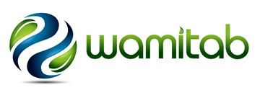

Specialist Call - Waste Sector and Learning and Development Specialists wanted for Technical Advisory Group!
To apply to join this forward-facing focus group, complete the form and submit along with a current CV to: info.admin@wamitab.org.uk
First Name: |  | Surname:
Employer: |  | Position:
Employer Profile (tick):

- Less than 10 employees
- 10-50 employees
- 50-250 employees
- 250+ employees

I confirm that I am available and able to commit to the following events:

- Initial Webinar: 10 am, Thursday 18th July 2019
- Meeting: 10 am – 2 pm, Tuesday 13th August 2019 (WAMITAB Office, Northampton)
- Findings Webinar: 10am – 12 noon, Thursday 29th August 2019

- If I am selected for membership of the EnviroHub Technical Advisory Group, I confirm that I agree to WAMITAB sharing my contact information with other members of the group and project team.
Signature:
Date:

WAMITAB, Peterbridge House, 3 The Lakes, Northampton NN4 7HE
www.wamitab.org.uk

